Week 5 Readings
Please complete the following readings:
- Read online lectures for Week 5
Read following chapters from the 3ds Max 2010 Bible
- Using Lights and Basic Lighting Techniques
- Working with Advanced lighting, Light Tracing, and Radiosity
Practice Exercises:
Complete the following short tutorial lessons from the 3ds Max 2010 Bible:
- From the Using Lights and basic Lighting techniques Chapter:
  - Lighting a snowman’s face
  - Lighting a lamp
  - Animating a day in 20 seconds
  - Showing car headlights
  - Creating Laser Beams
  - Project a trumpet image on a scene
  - Creating a stained-glass window
- From the Working with Advanced Lighting, Light Tracing and Radiosity Chapter:
  - Viewing Color Bleeding
  - Excluding Objects from Light Tracing
  - Preparing a mesh for radiosity
  - Lighting a house interior with radiosity
Week 5 Assignments Overview
Assignment Summary Week 5: | Due Date
Assignment 1: Practice Exercise | Wednesday, February 10, 2010
Assignment 2: Discussion: Placing Lights in a Scene | Friday, February 12, 2010
Using the navigation on the left, please proceed to the next page.

Week 5 Overview
During the last four weeks, you spent most of your time creating some wonderful models using the different modeling techniques available in 3ds Max. You also gave a touch of realism to the objects you modeled by applying different types of materials.
You will now learn to illuminate scenes by using the light effects in 3ds Max. You'll also learn to compose a scene and finally collate all your models to render a final scene.

Learning Outcomes:
• Students should be able to demonstrate the ability to properly light a 3D environment.
• Student should be able to demonstrate the ability to properly place a camera into a 3D environment to define the desired perspective viewing of the model.

Let's See Things Clearly
Things generally don't appear the same all times of a day. Take for example a huge tree in a garden. The tree appears as a symbol of strength and imparts a sense of security during daytime. However the same tree gives a spooky feeling during the night. While it gives a sense of serenity and purity in the morning, it might make you feel gloomy in the evening.
What's causing this change in emotions? Light!
A change in light has a tremendous effect on us. Light not only enables us to see objects around us, it also generates emotions in us. Professionals such as cinematographers, 3D game designers, and art directors realize the importance of light. This week we'll concentrate on lighting in 3D. We'll also look at cameras and rendering in 3ds Max.
The primary objective of light is to illuminate an area. However a deeper study of light unfolds the power of light to generate emotions in us. This study of light in the context of 3D design involves, but is not limited to the following areas:
- How light illuminates objects
- How light casts shadows
- How change in light affects a scene
Let's look at each of these areas.

How Light Illuminates Objects
When light strikes objects it illuminates them. Objects are illuminated either directly or indirectly. Direct illumination occurs when an object comes in the path of light from a source. In this case the surface of the object facing the light source is directly illuminated. For example if you keep a ball in front of a burning candle in a dark room, only the surface that faces the candle is illuminated.
Indirect illumination occurs when the surface of an object is not directly in the path of light from a source. Indirect illumination occurs because of the combination of numerous properties of light. Some important properties of light that cause indirect illumination are reflection, bending, refraction, and scattering. Let's look at each of these properties.

Reflection
Objects are illuminated by reflected light. For example the side of a tree that is not facing the sun is visible because it receives light from other objects, such as the ground and the stones around the tree. The objects around the tree are not light sources, but they reflect sunlight from their surfaces. This light illuminates the side surface of the tree.

Bending
A unique property of light is that it bends around objects and illuminates the surface of an object that is not in direct contact with the light. It's partly because of the bending of light that the edges of metal objects shine.

Refraction
When light passes from one medium to another, it changes its path; this is called refraction. For example when light passes through water, it changes its path. The refracted light illuminates the objects it falls on. However because of the changed path, these objects seem distorted. For example if you look through a glass jug full of water, you will see distorted objects at the other side of the jug. This distortion is because of the refraction of light.

Scattering
Objects are also illuminated when scattered light falls on them. Light scatters because of numerous dust particles present in the atmosphere. When light from a source strikes these particles, it's scattered in all directions. Objects receive this scattered light and are illuminated.

How Light Casts Shadows
Another interesting aspect of light is that it casts shadows. Some factors on which the characteristics of the shadow of an object depend are:
- Angle of light
- Intensity of light
- Transparency of the object

Angle of Light
The angle at which light falls on an object determines certain characteristics such as the length, proportion, and blurriness of the shadow of an object. For example the shadows of objects in the morning are longer, more disproportionate, and blurred than the shadows formed at noon. This is because sunrays fall on objects at different angles at different times in a day.

Intensity of Light
The intensity of light falling on an object also determines the characteristics of the shadow of the object. As the intensity of light increases, the edges of the shadows it casts become sharp and crisp and the shadow darkens.

Transparency of an Object
The degree of transparency of an object also affects the shadow of the object. The shadow of an opaque object is darker compared to the shadow of a semitransparent object. This is because some light passes through a semitransparent object and illuminates the area where the shadow of the object is formed.

How Change in Light Affects a Scene
As mentioned earlier modifying the attributes of light has a deep impact on a scene. The change could be in the color, intensity, extent, and angle of light. These changes produce different feelings in us.
A low-angle light from the back of an object coupled with a low-angle POV exaggerates the size of the object and creates a feeling of dread and tension. Filmmakers use this technique to create terrifying scenes. An example of this is a scene in which a monster is approaching the camera. In this case a light is positioned at the back of the monster.

Analyzing the Effect of Light
You can follow a simple three-step approach to comprehend and analyze the way light affects a scene: observe, experiment, and sketch.

Observe
Observe the light phenomena that occur in nature. Concentrate on shadow formation. Identify the areas in a scene that are illuminated by indirect lights. Also identify the objects that are responsible for indirect illumination.
In addition learn from the masters of lighting. Watch movies such as Matrix, Star Wars, and Saving Private Ryan to understand how filmmakers use lights to tell a story. You can also play 3D games and analyze the use of lights and shadows in them.

Experiment
Experiment with different angles and colors of light, and observe how these affect a scene. Don't restrict yourself to a single light. Examine how multiple lights illuminate objects and cast shadows. For example you can switch on several torches at different angles in a dark room and see how these lights affect the objects in the room.

Sketch
As you experiment with different light arrangements in a scene, keep sketching. This helps you comprehend the effect of light on a scene. Moving forward visualize the effect of varying light arrangements on a scene and draw sketches of these arrangements. Also make sketches of the scenes you liked in 3D games. These sketches will be useful when you design light arrangements for similar scenes.

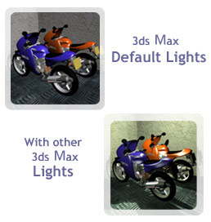
Types of Lights
During the last four weeks, you spent most of your time creating some wonderful models using the different modeling techniques available in 3ds Max. You also gave a touch of realism to the objects you modeled by applying different types of materials. You will now learn to illuminate scenes by using the light effects in 3ds Max. You'll also learn to compose a scene and finally collate all your models to render a final scene. It would be hard to imagine life without lights because lights illuminate our world. Lights not only illuminate our lives but also set the mood and overall look of a scene. Lights reveal objects and their colors. No lights would mean sheer darkness. It's because of light that our surroundings are colorful and beautiful.
Look at the graphics on the right. You'll see that the first graphic looks more realistic than the other because lights have been added to the first one. 3ds Max allows you to use various types of light. To create the desired effect you can add the appropriate type of light to a scene.
3ds Max features several types of lights, including default, ambient, spotlight, omni, and direct.
You can access Lights from the Create option on the main menu or under the Create panel in Command Panel.
Let's look at the important types of lights provided by 3ds Max to simulate various lighting arrangements.
Note: Every visual art offers several approaches to lighting, and 3D is not an exception. The lighting tools of 3ds Max are not limited to brightness and color. A 3D designer can use these tools in several ways to formulate a lighting style.

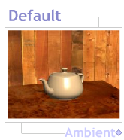
Default Light
In the previous weeks you didn't create any light in 3ds Max, and still your models were illuminated. This is because 3ds Max provides default lights for a scene. Max provides default lighting by placing two lights diagonally opposite to each other. This lighting technique is also known as cross lighting. These lights provide enough light for you to work, but it is preferable not to use them for final rendering, as you'll not get a professional look to your output. These lights illuminate all the objects created in a scene in a common manner. By default these lights do not appear in a scene. You can add these lights on a scene by configuring the rendering options on your viewport.
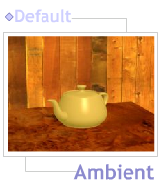
After you create the first light in a scene, the default lights stop working and it will be like they never existed. However, if you delete any lights that you add to your scene, the scene will becomes darker than before. You will need to restore the default lights on your viewport to retrieve the original default light setup for your scene.

Ambient Light
Ambient light represents the overall illumination of a scene and affects each model in the scene equally. The value of ambient light is generally restricted to darker shades of gray because increasing the value of ambient light decreases the contrast in a scene, which is undesirable. When you change the color of the ambient light used, the color of the scene changes.

Omni Light
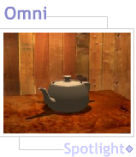
Omni light in 3ds Max can be compared to a bulb hanging in the air. Light spreads in all directions from an omni light. By default an omni light illuminates all the models in a scene. Omni lights are used frequently for illuminating a 3D scene. An omni light does not cast shadows by default. Casting shadows increases processing and rendering time. While creating objects by using modeling techniques, you have to repeatedly render your images for preview. The time taken to render should therefore not be long. After the modeling and assigning of materials in the scene have been finalized, the cast shadows option in the omni lights can be switched on.

Spotlight
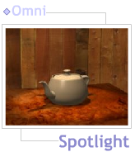
A spotlight in 3ds Max is similar to a spotlight used in theaters. By default, light from a spotlight is emitted in the shape of a cone, and the models that come in the path of this cone are illuminated. The shape of the cone can be changed to that of a rectangle. You can use a spotlight to highlight a specific element in a scene. Some areas where spotlight is used in the real world are still photography, video production, and movie production. You can also use a spotlight to represent various objects in the medical profession, for example, the light over a dentist's chair.
A spotlight can be of two types, target or free. A target spotlight has a source and a target. You can move the target and the source independent of each other. The target determines the direction of the cone of light emitted by the spotlight. You can use a target spotlight when you want to move the target independent of the source of light. For example, a target spotlight can be used to lend focus to a skater in the ring or a ballerina on the stage.
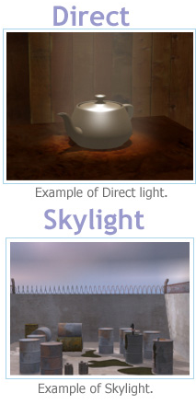
A free spotlight does not have an independent target. Therefore moving or rotating a free spotlight determines the direction of the cone of the spotlight. You can use a free spotlight to move the target along with the source of light. For example, a free spotlight can be used to simulate the headlights of a car.

Direct Light
In 3ds Max a direct light is similar to a spotlight. Unlike the spotlight, light from a direct light is emitted in the shape of a cylinder. As the light rays are parallel to each other and cast a shadow it can be used as sunlight. For example, you can use this to light to create a morning scene in a city and show long shadows made by the sun. Like spotlight, direct light can also be of two types, target and free.

Skylight
Skylight is a dome light that's not physically based, and can be used in all situations where physically based values are not required. Skylight represents the light coming from the sky or the environment, and provides an appropriate mood to the scene. It provides soft shadows—typical of a dome light. This light can be used in conjunction with other lights to create highlights and sharp shadows. Changing the color of the skylight helps indicate the time of the day. For example, a skylight with an orange color that gives the whole scene an orange tinge indicates dawn. This light is mainly used for outdoor effects.

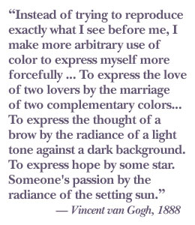
Color and Lighting

Colors and Moods
Colors add life to art. Art is a way of expressing yourself, and colors bring out the hidden expression in you. As an artist you need to be able to create the desired mood with a judicious use of colors. Creating an appropriate mood for a scene through the use of color generates audience interest.
The table below shows the moods conveyed by certain colors.
Mood | Color
Energy, power, and passion | Red
Cheer and clarity | Yellow
Peace and truth | Blue
Harmony and calm | Green
Spiritual | Purple
Purity | White
Understanding the basics of color can help us set a mood.

Primary Colors
Do you remember learning that red, yellow, and blue are known as primary colors from which all other colors are derived?
The color model used by artists is the Red Yellow Blue (RYB) model where red, yellow, and blue are treated as primary colors. Here we are dealing with art in the computer industry where the RGB—red, green, and blue—model is predominantly used.

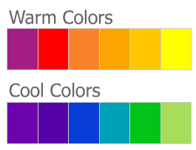
RGB Model
The RGB model is the color model for light. A computer monitor creates colors by mixing different proportions of red, green, and blue. A scale of 0 to 255 represents the intensity of each of these primary colors. When all the primary colors have a value of zero, the color obtained is black. Invariably black represents the absence of light. Similarly when all primary colors have a value of 255 each, white is obtained.
To set the mood of a scene colors are broadly divided into two categories, warm and cool. Given below are the differences between the two categories.

Warm vs. Cool Colors
Differentiating Factor | Warm Color | Cool Color
Color | Red, Orange, and Yellow | Green, Blue, and Violet
Intensity | High | Low
Mood | Energy and Anger. When there are only two items used "and" not a comma | Calm, Depression
Example | Sun and Fire | Forest, Water
Illusion of depth | Appears to advance towards the viewer | Appears to recede from the viewer
Note: Judicious use of warm and cool colors can help set the mood of a scene and create an illusion of depth.

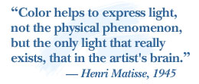
Understanding Lights
Had Henri Matisse been alive today the power of lighting using 3ds Max would have enthralled him. With the help of 3ds Max we can simulate both natural and artificial lights. We will discuss the use of lights in as a separate topic at the end of the course.
Take a minute now to observe the lighting in your room. Observe the reflective surfaces in the room. Are there objects in your room that appear to be of a different color because of the lights in the room? Wrap the source of light with a thin layer of red fabric or paper and see the effect in your room. Did the mood of your room change? Did you observe a link between color and light?

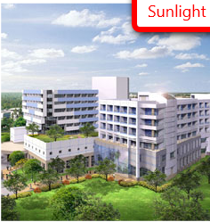
- Sunlight: Sunlight falls on objects in different hues and intensities during the length of a day. To gauge the intensity of sunlight at different times of a day, observe the world around you before creating scenes.
- Atmosphere: Atmospheric light depends on the quality of sunlight. The sun and the moon tend to appear larger at the horizon due to the impact of the atmosphere. Seasonal changes have an effect on sunlight. A foggy day appears hazy while a hot day is bright.
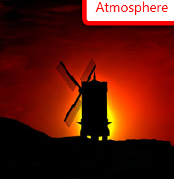
- Light in outer space: Space has no atmosphere. As a result there is no filtering of light. Light from surroundings (also called ambient light) is less in space. So the environment in space is illuminated to a bare minimum. A scene from outer space will have bright white light and nearly no ambient light.
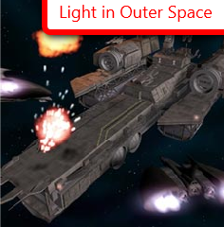
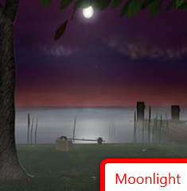
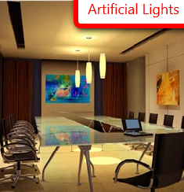
- Moonlight: Remember that the moon reflects light from the sun and is a weak source of light, so the amount of light reflected by its surfaces will be less than that emitted by the sun. A scene that portrays moonlight will have low illumination with minimum reflection.

- Artificial lights: Artificial lights are the source of indoor lighting and are of limited intensity. The most commonly used artificial light source is the bulb, which casts a warm light with an orange tinge. It is important for you to know about the impact of artificial lights on a scene.
Having looked at the different sources of light, let's see how colors and lights are mixed.

Mixing Lights and Colors
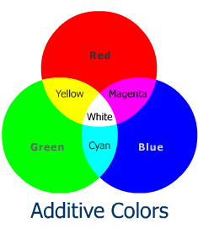
The mixing of colors and lights can be best understood through the concept of additive color mixing.
The process of mixing a combination of primary colors (RGB) to obtain a new color is called additive color mixing. In this technique light rays of different colors are combined to form a new colored ray. The new color is obtained by mixing different spectral wavelengths of light. The computer monitor can create a multitude of colors using the RBG model. Usually in such a model adding new color rays to a mixture makes the mixture bright. Because of this additive color mixing is widely used in films.
Look at the graphic to your right. Note that the colors cyan, yellow, and magenta are created by a partial overlap of primary colors. Also note that the white color is generated when all the primary colors completely overlap one another.

Lighting Techniques
Professional 3D designers look at lighting techniques as powerful methods to create mood in a 3D scene. Lighting a scene starts by providing basic illumination to the objects in a scene. Various techniques are used to provide basic illumination in a scene. To understand these techniques you should be familiar with some frequently used terms in lighting. Let's look at these terms.

Key Light
Key light or "Key" is generally the brightest light in a scene. This light is responsible for illuminating the objects in the scene. It is positioned at an angle of 30 or 40 degrees from the camera and maintains an angle of 45 degrees from the vertical axis of the scene. The Key generally casts shadows in a scene.

Backlight
Backlight is used to separate the objects in a scene from the background. Backlight is placed behind and above the objects in a scene. Backlight provides a subtle border around the objects in a scene. Generally the intensity of Backlight is less than or equal to that of Key.

Fill Light
Fill light or "Fill" is used to illuminate the parts of a scene that are not illuminated by the Key. This light is positioned towards the left of the camera. The intensity of Fill depends on the contrast that needs to be generated in a scene. A bright Fill reduces contrast whereas a dim Fill increases contrast between the various elements in a scene.
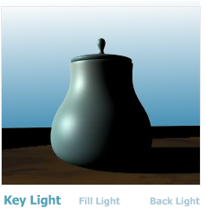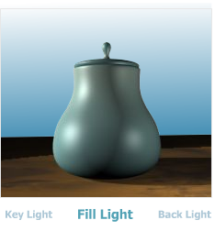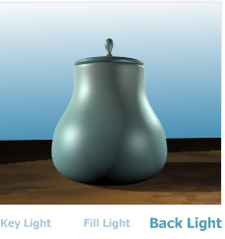
Some of the basic lighting techniques that are used by 3D designers are:
- Triangle lighting: This type of lighting involves the use of Key, Backlight, and Fill to illuminate a scene. The relative intensity of these three lights creates contrast and focus areas in the scene.
- Zone lighting: This type of lighting divides a scene into various zones depending on light requirements. Each of these zones is lit using the triangle lighting technique.
- Cross lighting: This type of lighting involves setting up two Keys diagonally across a scene. This technique gives basic illumination to the scene but does not create any mood. 3ds Max default lights use this technique.

It's a good practice to sketch a lighting arrangement on a piece of paper before actually placing lights in a 3D scene; we call this sketch a lighting diagram. In the diagram identify the areas that require more light, and pinpoint the areas where you don't want shadows.

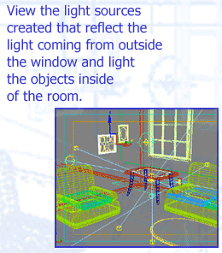
Illuminating Models and Scene
Every visual art has several styles of lighting, and 3D is not an exception. The lighting tools of 3ds Max are not limited to any aspect of lighting, such as brightness and color. A 3D designer can use these tools in several ways to formulate a lighting style.

The Angle of Incidence
Lighting in 3ds Max is based on the angle that a light source makes with a model and not the distance of the light from the model. The angle that a light source makes with a model is called the angle of incidence. When the angle of incidence is 90 degrees, illumination is more even than when the angle of incidence is less or more.

If the light is placed close to a model in a scene, an acute or obtuse angle of incidence creates gradations on the model. In contrast a 90-degree angle of incidence creates a hotspot on the model. As you increase the distance between a model and a light source, the angle between them is almost 90 degrees, even if the light is placed obliquely. This is the reason why a light placed away from a model illuminates the scene more evenly than when it is placed close to the model. This is in contrast to the real world where light intensity diminishes with distance. In 3ds Max the intensity of light can be controlled by attenuation parameters. You can use these parameters to show the effect of diminishing light.

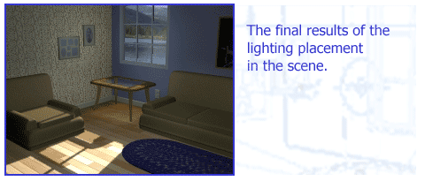
Direct and Indirect Illumination
Lighting in 3ds Max is also based on direct illumination. Therefore all the effects of indirect illumination need to be generated while working with lights in 3ds Max. For example to illuminate the surfaces of models that are not facing light, extra light sources have to be created that act as reflected light from other objects in the scene.
Certain tools such as raytracing trace the path of a reflected ray in 3ds Max to simulate reflections, but these tools are memory-intensive and use a lot of rendering time. Therefore the best approach is to understand lighting and create secondary sources of light that produce the effects of indirect illumination.
Look at the graphic displayed on this page. It shows a simple lighting arrangement that simulates the lighting in a room. There is no light source inside the room. The objects in the room are illuminated by the sunlight coming from the open window.
To simulate such a scene extra lights that create the effect of sunlight reflected from the floor, walls, and the ceiling are needed. The graphic displays the position and intensity of lights that need to be created to simulate this environment.

Let's now look at the important lighting tools provided by 3ds Max to simulate various lighting arrangements.

Default Lights
In the previous weeks you didn't create a light in 3ds Max, and still your models were illuminated. This is because 3ds Max provides default lights for a scene. The default lights follow the cross light technique of lighting. These lights provide enough light for you to work, but they are not meant for final rendering.
Default lights can't be moved or manipulated. When you create the first light in your scene, the default lights are switched off. Therefore the scene becomes darker than before.

Ambient Light
Another light that can't be moved in 3ds Max is ambient light. Ambient light represents the overall illumination of a scene and affects each model in the scene equally. The value of ambient light is generally restricted to darker shades of gray because increasing the value of ambient light decreases the contrast in a scene, which is undesirable.

Omni Light
An Omni light in 3ds Max is like a bulb hanging in the air. Light spreads in all directions from an omni light. So, by default, an omni light illuminates all the models in a scene. Omni lights are used frequently for illuminating a 3D scene.
An omni light does not cast shadows by default. This is because casting shadows increases processing and rendering time and, therefore, should be avoided if not necessary. However an omni light can be made to cast shadows if needed.

Spotlight
A spotlight in 3ds Max is similar to a spotlight used in theaters. Light from a spotlight is emitted in the shape of a cone. The models that come in the path of this cone are illuminated. You can use a spotlight when you want to highlight a specific element in a scene.
A spotlight can be targeted or free. A targeted spotlight has a target that can be moved independent of the spotlight. The target determines the direction of the cone of light emitted by the spotlight. You can use a targeted spotlight when you want to move a target independent of the source of light. For example a targeted spotlight can be used to simulate a skating event.
A free spotlight does not have an independent target. Therefore moving or rotating a free spotlight determines the direction of the cone of the spotlight. You can use a free spotlight when you want to move the target with the source of light. For example a free spotlight can be used to simulate the headlights of a car.
You have seen this week how to create lights and how to setup a scheme of lighting to create a mood in a 3D scene. Next week, you will continue developing your scene by adding an interesting camera angle and rendering the final scene.

Summary
This week you have explored lighting and how it affects the surface of geometry in your scene. You have explored lighting options and ways to make a scene lighting effective.
Proceed to complete the exercises on the Assignments section to put into practice the concepts learned in this week’s lectures and Reading Assignments.
Assignment 1: Practice Exercise
This week, you're seeing how to use lights. Complete the exercises listed on the Reading and Assignments section. By Wednesday, February 10, 2010, write a note on the areas listed below and post it to the Discussion Area along with the jpgs of the rendered exercises. Also by Wednesday, February 10, 2010, save your 3ds Max files for each of the exercises to the W5: Assignment 1 Dropbox.
Respond to the following self-evaluation areas:
- Which lesson do you find more valuable?
- Which problems did you encounter through the process and how you fixed the problem?
- List and provide an explanation of at least two concepts that you learned this week.
- Explain how you can apply the concepts included on this exercise to your final project (see Assignments 2 and 3 this week for more details on the final assignment).
By the end of the week, respond to at least two other student’s postings. Comment on their achievements and their findings included on their note. Post your responses to the Discussion Area.
Assignment 1 Grading Criteria: | Maximum Points
Successfully completed all practice exercises listed in the Reading and Assignments section. | 4
Included notes on the learning experience. | 4
Participated in class discussions. | 4
Total: | 12
For assistance with any problems you may have when completing this assignment—OR—to offer your assistance to classmates, please use the Problems and Solutions Discussion area located through the left side navigation link.
W5A1
Let's work with lights with week. I like the way you all have been posting pdfs. Let's continue to do that.

Assignment 2: Discussion: Placing Lights in a Scene
Create a lighting scheme for your scene and place appropriate lights in the scene of the 3D room. Consider a daytime scene with light coming in through a window, or perhaps a night scene with artificial lighting inside the room. Save your 3ds Max file as LastName_W5_A2.max and render your scene as LasName_W5_a2.jpg.
Post the 3ds Max file to the W5: Assignment 2 Dropbox and the rendered .jpg files to this Discussion Area by Friday, February 12, 2010 . Along with the rendered jpg(s) post a self-review using the following questions:
- Did you achieve your lighting goals?
- Which areas of the project are you satisfied with?
- Which areas of the project do you believe you could improve?
- Which difficulties did you find during the lighting process? How did you solve these difficulties (which solutions worked for you)?
Before the end of the week, critique the work posted by at east two other classmates. Discuss all of the following:
- Which areas were most successful? Discuss the application of this week’s concepts to the work.
- Which areas could use improvements?
- Provide ideas or tips on how to improve these areas based on what you have learned this week.
NOTE:
Post a revision for your lighting on the scene based on the feedback received in class by Sunday, February 14, 2010. Post your revised scene to the Dropbox for this assignment, and the jpg to this Discussion Area as well.
Assignment 2 Grading Criteria: | Maximum Points
Lighting scheme uses proper intensity, color, and placement for the time of day or mood intended. | 5
Proper shadows casting on scene elements, considering color, edge, intensity of shadows and distance. | 5
Light sources are well defined. | 5
Instructions were followed with output delivered in the specified file formats and required naming conventions. | 4
Student responded thoughtfully to self-critique questions. | 5
Student critiqued at least two other students work based on the critique guidelines. | 4
Total | 28
For assistance with any problems you may have when completing this assignment—OR—to offer your assistance to classmates, please use the Problems and Solutions Discussion area located through the left side navigation link.
W5A2
Let's light your scenes now. Please post a series of images that show off your scene with lighting as pdfs.

